RESOLUTION: 009-2016
ADOPTED:

A RESOLUTION DECLARING municipal personal property (salt spreader) is not needed for MUNICIPAL PURPOSES/public use, or is obsolete or unfit for the use for which it was acquired, and that the property has little or no value AND DECLARING AN EMERGENCY

WHEREAS, disposal of municipal personal property unneeded, obsolete, or unfit for municipal purposes is governed by R.C. 721.15; and

WHEREAS, R.C. 721.15(A) allows the legislative authority of a municipal corporation to sell personal property not needed for municipal purposes, the estimated value of which is less than one thousand dollars, by the board or officer having supervision or management of that property, and

WHEREAS, R.C. 721.15(C) allows the legislative authority of a municipal corporation to determine when municipal personal property is not needed for public use, or is obsolete or unfit for the use for which it was acquired, and that the property has no value, and then discard or salvage that property; and

NOW, THEREFORE BE IT RESOLVED, by the Council of the Village of Glenford, County of Perry County, State of Ohio that:

SECTION 1: Council for the Village of Glenford hereby finds the following equipment is not needed for municipal purposes/public use or is obsolete or unfit for the use for which it was acquired, and that the property has no little or no value (maybe $100.00):

- Salt Spreader

SECTION 2: Pursuant to R.C. 721.15(A) or (C), the Village Administrator or his designee is hereby authorized to sell, discard, or salvage the municipal personal property identified in Section 1.

SECTION 3: All prior legislation, or any parts thereof, which is/are inconsistent with this Resolution is/are hereby repealed as to the inconsistent parts thereof.

SECTION 4: It is hereby found and determined that all formal actions of this Council concerning and relating to the passage of this Resolution were adopted in an open meeting of Council and that all deliberations of the Council and any of the decision making bodies of the Village of Glenford which resulted in such formal actions were in meetings open to the public in compliance with all legal requirements of the State of Ohio.

SECTION 5: Council declares this to be an emergency measure immediately necessary for the preservation of the public peace, health, and safety of this municipality and the further reason that the Village wants to sell, discard, or salvage this municipal personal property as soon as possible. Wherefore, provided this Resolution receives the required affirmative votes of Council, this Resolution shall take effect and be in force immediately upon passage by Council

Passed in Council this _______ day of __________ 2016.

____________________________

Leonard Sheppard, Mayor

ATTEST:

Linda Nicodemus, Fiscal Officer

APPROVED:
Approved as to form this 26th day of April 2016.
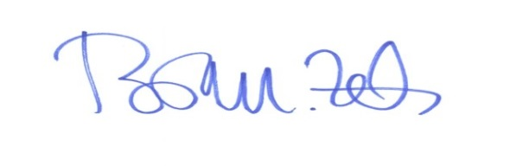
_________________________
Brian M. Zets, Esq.
Village Solicitor

