RESOLUTION: 003-2015
ADOPTED:

A RESOLUTION AUTHORIZING AND DIRECTING THE FISCAL OFFICER TO TRANSFER MONEY FROM THE WATER FUND TO THE GENERAL FUND AND DECLARING AN EMERGENCY

WHEREAS, in 2011, the Village of Glenford used money from the General Fund when the water system was being constructed because the Water Funds had not been established yet. This money needed to be transferred into the Water Fund; and

WHEREAS, the total amount that was to be transferred from the General Fund to the Water Fund was Twenty Thousand Dollars and No Cents ($20,000.00); and

WHEREAS, with Resolution No. 2011-07, adopted August 1, 2011, Council for the Village of Glenford authorized the transfer of Three Hundred Dollars ($300.00) per month for only thirty-six (36) months. Because this repayment/transfer plan was incorrectly calculated, the General Fund was not fully repaid; and

WHEREAS, it recently was brought to Council’s attention that an additional Eleven Thousand Two Hundred Dollars and No Cents ($11,200.00) must be transferred from the Water Fund to the General Fund; and

WHEREAS, Council for the Village of Glenford now wants to establish a repayment plan so that the remaining $11,200.00 will be transferred from the Water Fund to the General Fund.

NOW, THEREFORE BE IT RESOLVED, by the Council of the Village of Glenford, County of Perry County, State of Ohio that:

SECTION 1: Council for the Village of Glenford hereby authorizes and directs the Fiscal Officer, beginning in August 2015 and for the next fourteen (14) consecutive months, to transfer Eight Hundred Dollars and No Cents ($800.00) per month from the Water Fund to the General Fund.

SECTION 2: All prior legislation, or any parts thereof, which is/are inconsistent with this Resolution is/are hereby repealed as to the inconsistent parts thereof.

SECTION 3: It is hereby found and determined that all formal actions of this Council concerning and relating to the passage of this Resolution were adopted in an open meeting of Council and that all deliberations of the Council and any of the decision making bodies of the Village of Glenford which resulted in such formal actions were in meetings open to the public in compliance with all legal requirements of the State of Ohio.

SECTION 4: Council declares this to be an emergency measure immediately necessary for the preservation of the public peace, health, and safety of this municipality and the further reason that the Village must start transferring this money as soon as possible in order to provide adequate accounting of its fund balances. Wherefore, provided this Resolution receives the required affirmative votes of Council, this Resolution shall take effect and be in force immediately upon passage by Council

Passed in Council this _______ day of __________ 2015.

____________________________

Leonard Sheppard, Mayor

ATTEST:

Linda Nicodemus, Fiscal Officer

APPROVED:

Approved as to form this 3rd day of August 2015.
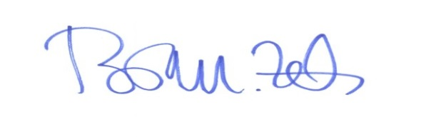
_________________________
Brian M. Zets, Esq.
Village Solicitor

