RESOLUTION: 005-2016
ADOPTED: ____________________

A RESOLUTION AUTHORIZING THE VILLAGE ADMINISTRATOR TO ACCEPT THE BID OF FAMILY TREE LAWNCARE, AUTHORIZING THE VILLAGE ADMINISTRATOR AND FISCAL OFFICER TO EXECUTE AN AGREEMENT FOR MOWING SERVICES WITH FAMILY TREE LAWNCARE, AND DECLARING AN EMERGENCY

WHEREAS, although Council for the Village of Glenford did not anticipate the estimated Village mowing contract would exceed the threshold bid amount set forth in R.C. 731.141, the Village requested bids anyway; and

WHEREAS, the Village of Glenford received three (3) bid responses; and

WHEREAS, while all bids were competitive and closely matched, Family Tree Lawncare’s bid was the lowest. In addition, Council for the Village of Glenford believes Family Tree Lawncare will perform these services timely and with reasonable skill and care; and

NOW, THEREFORE, BE IT RESOLVED by the Council of the Village of Glenford, County of Perry, State of Ohio:

Section 1: Council for the Village of Glenford hereby authorizes and directs the Village Administrator to accept the bid of Family Tree Lawncare for mowing municipally-owned property.

Section 2: The Village Administrator and Fiscal Officer are hereby authorized and directed to execute all documents necessary so that Family Tree Lawncare can begin mowing this month.

SECTION 3: All prior legislation, or any parts thereof, which is/are inconsistent with this Resolution is/are hereby repealed as to the inconsistent parts thereof.

SECTION 4: It is hereby found and determined that all formal actions of this Council concerning and relating to the adoption of this Resolution were adopted in an open meeting of this Council, and that any and all deliberations of this Council and any of its committees that resulted in such formal action were in meetings open to the public, in compliance with all legal requirements of the laws of the State of Ohio.

SECTION 5: Council declares this to be an emergency measure immediately necessary for the preservation of the public peace, health, and safety of this municipality and the further reason that the Village needs to enter into this contract immediately so that mowing, which is needed, can commence as soon as possible. Wherefore, provided this Resolution receives the required affirmative votes of Council, this Resolution shall take effect and be in force immediately upon passage by Council.

Passed in Council this _______ day of April 2016.

____________________________

Leonard Sheppard, Mayor

ATTEST:

Linda Nicodemus, Fiscal Officer

APPROVED:

Approved as to form this 4th day of April 2016
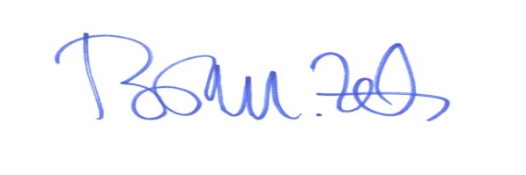
_________________________
Brian M. Zets, Esq.
Village Solicitor

