ORDINANCE N. 15-002

AN ORDINANCE AMENDING ORDINANCE 13-006, SECTION 2 (UTILITY CLERK PAY) AND DECLARING AND EMERGENCY

WHEREAS, with Ordinance 13-006, adopted August 6, 2013, Council for the Village of Glenford increased the Utility Clerk’s pay from Two Hundred Fifty Dollars per month to Five Hundred Dollars per month. No increase was made in 2014; and
WHEREAS, Council for the Village of Glenford appreciates the hard work being done by the Utility Clerk and recognizes the additional work that will need done once the Sewer Treatment Plant is operational; and
WHEREAS, Council for the Village of Glenford would like to again increase the Utility Clerk’s pay.
NOW, THEREFORE, BE IT ORDAINED by the Council of the Village of Glenford, County of Perry, State of Ohio:

Section 1: Ordinance 13-006, Section 2 shall be amended to read as follows:
The Village of Glenford Utility Clerk’s gross pay shall be $700 per month, which shall be paid half from the Water Fund and half from the Sewer Fund.
SECTION 2: All other Sections of Ordinance 13-006 shall remain unchanged, effective, and enforceable.
SECTION 3: All prior legislation, or any parts thereof, which is/are inconsistent with this Ordinance is/are hereby repealed as to the inconsistent parts thereof.

SECTION 3: It is hereby found and determined that all formal actions of this Council concerning and relating to the adoption of this Ordinance were adopted in an open meeting of this Council, and that any and all deliberations of this Council and any of its committees that resulted in such formal action were in meetings open to the public, in compliance with all legal requirements of the laws of the State of Ohio.

SECTION 4: Council declares this to be an emergency measure immediately necessary for the preservation of the public peace, health, and safety of this municipality and the further reason that Council wants to increase the Utility Clerk’s pay immediately. Wherefore, provided this Ordinance receives the required affirmative votes of Council, this Ordinance shall take effect and be in force immediately upon passage by Council.

Passed in Council this _______ day of __________ 2015

____________________________

Leonard Sheppard, Mayor

ATTEST:

Linda Nicodemus, Fiscal Officer

APPROVED: Approved as to form this 9th day of February 2015.
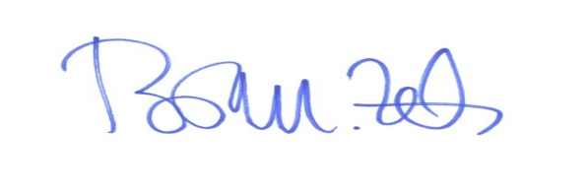
_________________________
Brian M. Zets, Esq. - Village Solicitor

