RESOLUTION NO 003-2014

A RESOLUTION AUTHORIZING THE MAYOR TO APPLY FOR, ACCEPT, AND ENTER INTO A WATER POLLUTION CONTROL FUND AGREEMENT ON BEHALF OF THE VILLAGE OF GLENFORD FOR PLANNING, DESIGN, AND/OR CONSTRUCTION OF WASTEWATER FACILITIES, DESIGNATING A DEDICATED REPAYMENT SOURCE FOR THE LOAN, AND DECLARING AN EMERGENCY

WHEREAS, the Village Of Glenford seeks to upgrade its existing wastewater facilities; and

WHEREAS, the Village of Glenford needs to apply for a Water Pollution Control Loan Fund (WPCLF) for the planning, design, and/or construction of the wastewater facilities; and

WHEREAS, because the Ohio Water Pollution Control Loan Fund requires the governmental authority to pass legislation for application of a loan and the execution of an agreement as well as designating a dedicated repayment source, Council for the Village of Glenford now wants to take such action.

NOW, THEREFORE, BE IT RESOLVED by the Council for the Village of Glenford, Perry County, Ohio that

SECTION 1: The Mayor, on behalf of the Village of Glenford, is hereby authorized and directed to apply for and accept a WPCLF loan as well as execute all documents necessary for, and to enter into, a WPCLF with the Ohio Environmental Protection Agency and the Ohio Development Authority for planning, design, and/or construction of wastewater facilities.

SECTION 2: The dedicated repayment source for the WPCLF will be the Sewer Fund.

SECTION 3: All prior legislation, or any parts thereof, which is/are inconsistent with this Resolution is/are hereby repealed as to the inconsistent parts thereof.

SECTION 4: It is hereby found and determined that all formal actions of this Council concerning and relating to the adoption of this Resolution were adopted in an open meeting of this Council, and that any and all deliberations of this Council and any of its committees that resulted in such formal action were in meetings open to the public, in compliance with all legal requirements of the laws of the State of Ohio.

SECTION 5: Council declares this to be an emergency measure immediately necessary for the preservation of the public peace, health, and safety of this municipality and the further reason that the Village needs to adopt this Resolution immediately so the loan application can be completed as soon as possible. Wherefore, provided this Resolution receives the required affirmative votes of Council, this Resolution shall take effect and be in force immediately upon passage by Council.

Passed in Council this _______ day of __________________ 2014

Leonard Sheppard, Mayor

ATTEST:

Linda Nicodemus, Fiscal Officer APPROVED: Approved as to form this 4th day of January 2014:
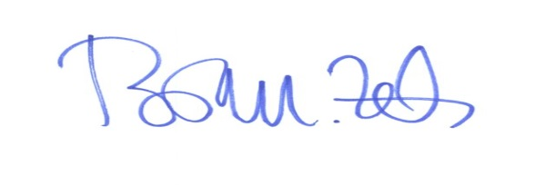
Brian M. Zets, Esq. Village Solicitor

