Resolution 001-2016

Resolution Of Support For The Village Of Glenford
Boat Launch

WHEREAS, the Village of Glenford recognizes the pristine Jonathan Creek, which is tributary from Buckeye Lake to the beautiful Muskingum River, and the value of the Creek to the residents of our Village.

WHEREAS, the residents of the Village of Glenford may enjoy the Jonathan Creek from its beautiful banks, there are no access points along the creek to allow Village residents or Perry County residents to enjoy water activities on the creek; and

WHEREAS, with education and increased access to the Jonathan Creek, an increased appreciation of the creek may be fostered, highlighting its natural benefits; and

WHEREAS, the Perry County Soil and Water Construction District has received funding to purchase land located in the Village of Glenford and other locations in Perry County through a grant award from the Clean Ohio Program; and

WHEREAS, these locations will be for public access for our residents by construction of boat launches suitable for canoes, kayaks and other similar water activities; and

WHEREAS, the construction of the launch in the Village, with connection to other launches on the Jonathan Creek, will enhance this beautiful water course; and

WHEREAS, the Perry County Soil and Water Construction District may conduct guided floating tours of the creek on the “Jonathan Water Trail,” which will flow through the Village.

NOW, THEREFORE, BE IT RESOLVED, that the Village of Glenford “launches” this resolution with the full “floating” support of this community and the Village Council and with the hope that all construction being initiated “sail along” without difficulty or delay.

Passed in Council this ___ day of March 2016.

________________________________________
Leonard Sheppard, Mayor

ATTEST: ___________________________
Linda Nicodemus, Fiscal Officer

APPROVED:

Approved as to form this 1st day of March 2016:
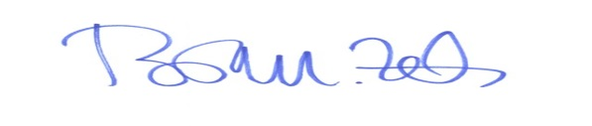
_________________________
Brian M. Zets, Esq.
Village Solicitor

