RESOLUTION NO 002-2015

A RESOLUTION AUTHORIZING AND DIRECTING THE VILLAGE ADMINISTRATOR TO EXECUTE WORK EXPERIENCE PROGRAM SITE AGREEMENT WITH PERRY COUNTY JOB AND FAMILY SERVICES AND DECLARING AN EMERGENCY

WHEREAS, Perry County Job & Family Services (PCJFS) has a Work Experience Program (WEP) whereby PCJFS provides qualified candidates to work for sponsor organization; and
WHEREAS, PCJFS assigns participants to meet the needs of its WEP Sponsors, helps provide for an efficient operation of the program, and even provides Ohio Worker’s Compensation for all individuals placed through the WEP; and
WHEREAS, the Village of Glenford believes it has opportunities to hire qualified individuals to perform various jobs around the Village and would like to take advantage of the WEP by becoming a sponsor.
NOW, THEREFORE, BE IT RESOLVED by the Council of the Village of Glenford, County of Perry, State of Ohio:

Section 1: Council for the Village of Glenford hereby authorizes and directs the Village Administrator to execute a Work Experience Program Sponsor Agreement with Perry County Job & Family Services. This Agreement shall be for one year, unless terminated.
SECTION 2: All prior legislation, or any parts thereof, which is/are inconsistent with this Resolution is/are hereby repealed as to the inconsistent parts thereof.

SECTION 3: It is hereby found and determined that all formal actions of this Council concerning and relating to the adoption of this Resolution were adopted in an open meeting of this Council, and that any and all deliberations of this Council and any of its committees that resulted in such formal action were in meetings open to the public, in compliance with all legal requirements of the laws of the State of Ohio.

SECTION 4: Council declares this to be an emergency measure immediately necessary for the preservation of the public peace, health, and safety of this municipality and the further reason that the Village would like to become a WEP Sponsor immediately so it can take advantage of the program and hire someone as soon as possible. Wherefore, provided this Resolution receives the required affirmative votes of Council, this Resolution shall take effect and be in force immediately upon passage by Council.

Passed in Council this _______ day of __________ 2015.

____________________________

Leonard Sheppard, Mayor

ATTEST:

Linda Nicodemus, Fiscal Officer

APPROVED:

Approved as to form this 3rd day of April 2015.
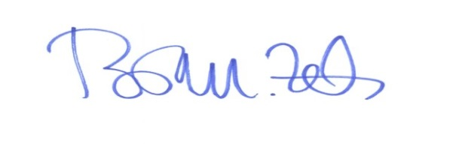
_________________________
Brian M. Zets, Esq.
Village Solicitor

