ORDINANCE NO 14-003

AN ORDINANCE CREATING AND ESTABLISHING A SEWER ENTERPRISE IMPROVEMENT FUND (FUND NO 5701) AND DECLARING AND EMERGENCY

WHEREAS, for some time, the Village of Glenford, Ohio, has been working hard to plan and build a Sanitary Sewer Containment and Treatment System (“Sanitary System”); and

WHEREAS, the Sanitary System will include, but not be limited to, a complete collection system to collect sewer from all Village households and businesses and consist of a traditional gravity sewer system, manholes, piping, service lines, fencing and a centralized treatment plant/filtration system; and

WHEREAS, in order to help finance the Sanitary System, the Ohio Public Works Commission, the Ohio Water Development Authority, and other funding sources have provided the Village of Glenford with various grants and loans; and
WHEREAS, the Village of Glenford needs to establish a sanitary sewer construction fund in order to properly account for all money being received, and paid out, to construct the Sanitary System.
NOW, THEREFORE, BE IT ORDAINED by the Council for the Village of Glenford, Perry County, Ohio that

SECTION 1: Council for the Village of Glenford hereby creates and establishes a “Sewer Enterprise Improvement Fund” (Fund Number 5701) for the receipt, deposit, accounting, and payment distribution of all money needed to design and construct the Village of Glenford Sanitary Sewer Containment and Treatment System, including, but not be limited to, a complete collection system to collect sewer from all Village households and businesses and consist of a traditional gravity sewer system, manholes, piping, service lines, fencing and a centralized treatment plant/filtration system.
SECTION 2: All money from the Ohio Public Works Commission, the Ohio Water Development Authority, and any other funding source, which is related to this project’s design and construction, shall be deposited into this Fund. In addition, Council for the Village of Glenford may appropriate other money to the Fund, as deemed necessary.
SECTION 3: The money deposited in this fund shall be kept separate and apart from all other money of the Village and shall be dedicated to the specific purpose for which the Sewer Enterprise Improvement Fund is created and established.
SECTION 4: It is hereby found and determined that all formal action of this Council concerning and relating to the passage of this Ordinance were adopted in open meeting of this Council, and that any and all deliberations of this Council and any of its committees that resulted in such formal action were in meetings open to the public, in compliance with all legal requirements of the laws of the State of Ohio.

SECTION 5: All prior legislation, or any parts thereof, which is/are inconsistent with this Ordinance is/are hereby repealed as to the inconsistent parts thereof.

SECTION 6: Council declares this to be an emergency measure immediately necessary for the preservation of the public peace, health, and safety of this municipality and the further reason that the Village must establish this fund immediately so that money can be deposited and payments can be made. Wherefore, provided this Ordinance receives the required affirmative votes of Council, it shall take effect and be in full force immediately upon passage.

Passed in Council this _______ day of __________________ 2014

Leonard Sheppard, Mayor

ATTEST:

Linda Nicodemus, Fiscal Officer

APPROVED:

Approved as to form this 5th day of August 2014:
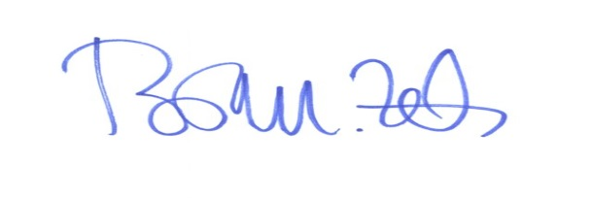
Brian M. Zets, Esq.
Village Solicitor

