ORDINANCE NO 15-005

AN ORDINANCE AMENDING THE VILLAGE OF GLENFORD SANITARY SEWER SYSTEM REGULATIONS, CHAPTER II, SECTION D (USER CHARGE) AND DECLARING AN EMERGENCY

WHEREAS, with Ordinance No. 15-001 adopted February 3, 2015, Council for the Village of Glenford adopted its Sanitary Sewer System Regulations. These Regulations established many guidelines, policies, procedures, rates, and penalties for the safe and efficient operation of the sanitary sewer collection and treatment system owned by the Village; and
WHEREAS, in February 2015, Council for the Village of Glenford still was working with ADR & Associates, Ltd. to collect relevant date and finalize the loan/grant money. Consequently, the User Charge set forth in Chapter II, Section D was left blank; and
WHEREAS, all the relevant and necessary information has been evaluated, and Council for the Village of Glenford now needs to formally establish the User Charge.
NOW, THEREFORE, BE IT ORDAINED by the Council of the Village of Glenford, County of Perry, State of Ohio:

Section 1: Chapter II, Section D (User Charge) of the Village of Glenford Sanitary Sewer System Regulations shall be amended to read as follows:
- The residential user fee shall be a flat, monthly fee of $52.00 per ERU. Nonresidential users shall be charged the monthly residential rate times the number of ERUs in accordance with “USER CATEGORIES AND ERU CRIERIA” found in Exhibit A. The monthly sewer rates and charges shall become effective upon acceptance of the sewer system by the Village for all users. The monthly sewer rate for all new customers of the Village Sanitary Sewer System who were not an initial user when the system first began operating will become effective upon connection to the system.
SECTION 2: All other Chapters, Sections, and Sub-sections of the Village of Glenford Sanitary Sewer System Regulations shall remain unchanged, in effect, and enforceable.

SECTION 3: All prior legislation, or any parts thereof, which is/are inconsistent with this Ordinance is/are hereby repealed as to the inconsistent parts thereof.

SECTION 4: It is hereby found and determined that all formal actions of this Council concerning and relating to the adoption of this Ordinance were adopted in an open meeting of this Council, and that any and all deliberations of this Council and any of its committees that resulted in such formal action were in meetings open to the public, in compliance with all legal requirements of the laws of the State of Ohio.

SECTION 5: Council declares this to be an emergency measure immediately necessary for the preservation of the public peace, health, and safety of this municipality and the further reason that the Village must establish and create this User Charge as soon as possible so that the Village can meet its obligations. Wherefore, provided this Ordinance receives the required affirmative votes of Council, this Ordinance shall take effect and be in force immediately upon passage by Council.

Passed in Council this _______ day of __________ 2015

____________________________

Leonard Sheppard, Mayor

ATTEST:

Linda Nicodemus, Fiscal Officer

APPROVED:

Approved as to form this 28th day of July 2015.
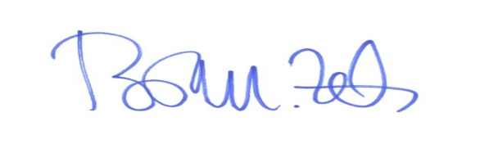
_________________________
Brian M. Zets, Esq.
Village Solicitor

